**Introduction to Power BI, Charts, DAX & Creating Reports**

**Question & Answer:**

**Question 1 : Define Power BI and What are the key components of the Power BI ecosystem? Briefly explain:**

**Answer**: Power BI is a cloud-based business intelligence (BI) and data visualization platform that enables users to create reports, dashboards, and analytics from various data sources. Key Components of the Power BI Ecosystem are: Power BI Desktop, Power BI Service (Cloud),Power BI Mobile, Power BI Report Server, Power BI Gateway, Power BI Embedded, Power Query, DAX (Data Analysis Expressions), Power BI Dataflows, Power BI Visuals Marketplace

* Power BI Desktop - A free Windows application used to connect to data, transform it, and create reports and dashboards. It’s mainly used by data analysts to design and build visualizations and data models.
* Power BI Service - A cloud-based platform (accessible via browser) where users can publish, share, and collaborate on reports and dashboards. It also supports real-time data monitoring and alerts
* Power BI Mobile - Mobile apps for iOS, Android, and Windows devices that allow users to view and interact with reports and dashboards on the go. It supports notifications and real-time data updates.
* Power BI Gateway - A bridge that connects on-premises data sources (like SQL Server or Excel files) to Power BI Service, allowing scheduled data refresh and secure data transfer between local systems and the cloud.

**Question 2 : Compare the following Power BI visuals:**

**● Pie Chart vs Donut Chart**

**● Bar Chart vs Column Chart**

**When would you prefer one over the other? Give one example for each pair.**

**Answer** : Pie Chart vs Donut Chart:

| **Feature** | **Pie Chart** | **Donut Chart** |
| --- | --- | --- |
| Shape | Circle divided into slices | Similar to pie, but with a hole in the middle |
| Center Space | No center space | Has center space (can show labels or totals) |
| Readability | Can be hard to read with many categories | Slightly better, center space reduces clutter |
| Use Case | Show part-to-whole relationships | Same as pie, but more aesthetic or informative |
| Customization | Limited space for data labels | Extra space for adding total or description |

Prefer Pie Chart when:  
We have 2–4 categories and want a simple comparison.  
Example: Market share of 3 competing companies.

Prefer Donut Chart when:  
We want a more modern visual or need to display a total in the center.  
Example: Budget breakdown with total amount shown in the center.

**Bar Chart vs Column Chart:**

| **Feature** | **Bar Chart** | **Column Chart** |
| --- | --- | --- |
| Orientation | Horizontal bars | Vertical columns |
| Best For | Long category names, many categories | Time-based or sequential data |
| Label Visibility | Better for long text labels | Less space for labels |
| Visual Impact | Easier to compare across categories | Better for trends over time |

**Prefer Bar Chart** when:  
You have **long category names** or need to **rank items**.  
**Example**: Sales by product names like "Ultra Performance Engine Oil".

**Prefer Column Chart** when:  
You're showing **time-series data** (e.g., by month or year).  
**Example**: Monthly sales trend for the year 2025.

**Question 3 : Explain the significance of:**

**● Star schema vs Snowflake schema**

**● Primary key vs Foreign key in relationships (Power BI)**

**Why is cardinality important ?**

**Answer:** The significance of Star schema vs Snowflake schema are as follows :**-**

| Feature | Star Schema | Snowflake Schema |
| --- | --- | --- |
| Structure | Central fact table with denormalized dimension tables | Central fact table with normalized (multi-level) dimension tables |
| Simplicity | Simple, easy to understand and design | More complex with multiple related tables |
| Performance | Faster queries (fewer joins) | Slower performance (more joins) |
| Use in Power BI | Preferred for Power BI models | Can work, but may reduce performance and readability |

Primary Key vs Foreign Key in Power BI Relationships :-

| **Term** | **Primary Key** | **Foreign Key** |
| --- | --- | --- |
| Definition | A column (or set of columns) with unique values in a table | A column that contains values that match the primary key in another table |
| Role in Power BI | Exists in dimension table (e.g., Product ID) | Exists in fact table (e.g., Product ID) |
| Purpose | To uniquely identify each row | To link to the related row in another table |

Cardinality is important because:

* It affects how filters propagate across tables
* Incorrect cardinality can lead to wrong or duplicated results
* Power BI uses it to optimize queries and performance

**Question 4 : Differentiate between: Calculated column vs Measure. Also, define Row context and Filter context with simple examples.**

**Answer :** Difference between Calculated column vs Measure are as follows:-

| **Feature** | **Calculated Column** | **Measure** |
| --- | --- | --- |
| Definition | A new column added to a table using DAX | A dynamic calculation evaluated at query time using DAX |
| Calculated For | Each row in a table | Aggregated result based on filters/context |
| Stored In Model? | Yes (uses memory) | No (calculated on-the-fly, more efficient) |
| Use Case | When you need a value per row | When you need totals, averages, ratios |
| Performance | Slower for large data models | Faster and more efficient |

**Row Context** :

1. Applies when evaluating expressions for each row (e.g., in calculated columns or iterators like SUMX).

2. Think of it as: “I’m looking at this one row right now.”

**Example:** DiscountedPrice = Sales[UnitPrice] * 0.9

Filter Context

1. Comes from filters applied in visuals, slicers, or DAX functions.
2. It determines what subset of data is used when evaluating a measure.

**Example:** Total Sales = SUM(Sales[TotalPrice])

**Question 5: What is the difference between a report and a dashboard in Power BI?**

**Answer:** In Power BI, both reports and dashboards are used to visualize and analyze data, but they serve different purposes and have key differences:

1. Definition

* Report: A multi-page visualization that allows detailed exploration of data. Created in Power BI Desktop or Power BI Service.
* Dashboard: A single-page, real-time summary of key metrics, created only in Power BI Service, often called a "canvas."

2. Pages

* Report: Can have multiple pages, like a slideshow with tabs.
* Dashboard: Only one page (single canvas) that contains visual tiles.

3. Data Sources

* Report: Connects directly to one dataset.
* Dashboard: Can pull visualizations (tiles) from multiple reports and datasets.

4. Interactivity

* Report: Highly interactive – users can filter, slice, drill down, and interact with visuals.
* Dashboard: Limited interactivity – mainly for viewing; clicking tiles can navigate to underlying reports.

5. Creation Tool

* Report: Built in Power BI Desktop or Power BI Service.
* Dashboard: Built only in Power BI Service.

6. Use Case

* Report: For in-depth analysis and exploration of data trends.
* Dashboard: For executive summaries or monitoring key metrics at a glance.

**Question 6 : Using the Sample Superstore dataset:**

**● Create a Clustered Bar Chart to display Total Sales by Sub-Category**

**● Create a Donut Chart for Sales % by Region**

**Provide screenshots of both visuals**

**Answer: Here is the following chart :**

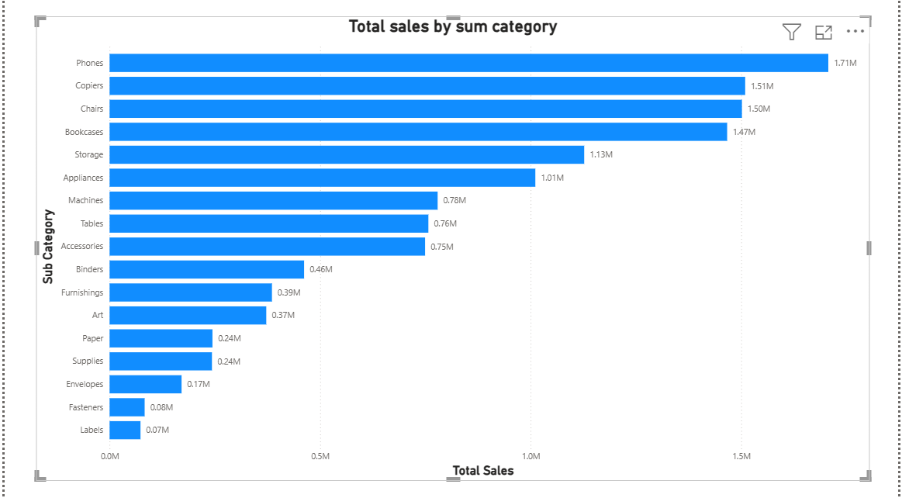

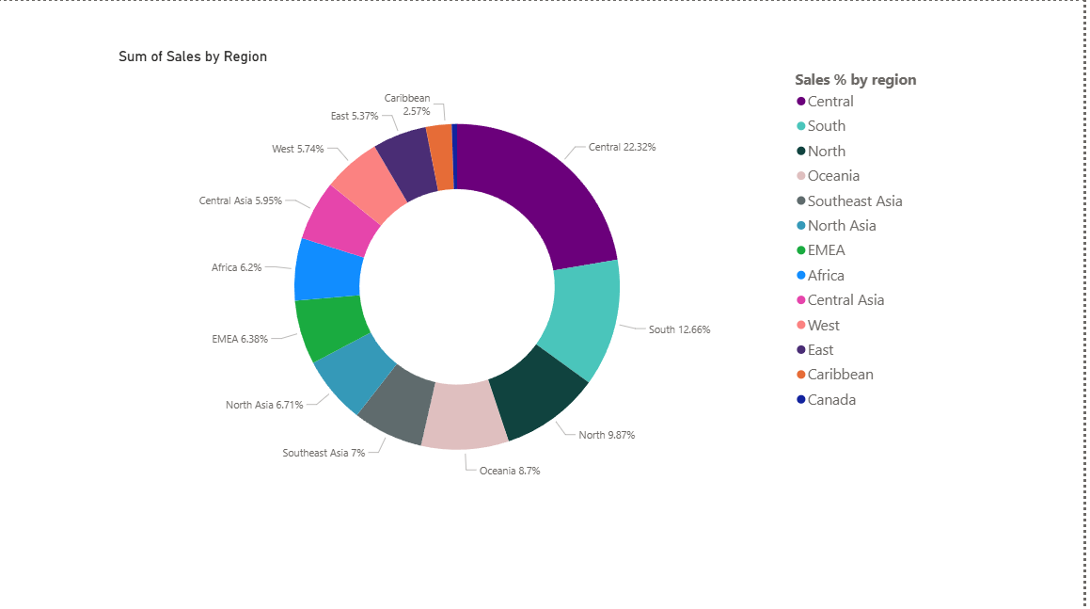

**Question 7: Write and apply the following measures:**

**● Total Profit = SUM([Profit])**

**● Average Discount = AVERAGE([Discount])**

**Display both in a KPI Card, and use a Line Chart to show profit trend over**

**months. Add visuals and DAX formulas.**

**Answer:**

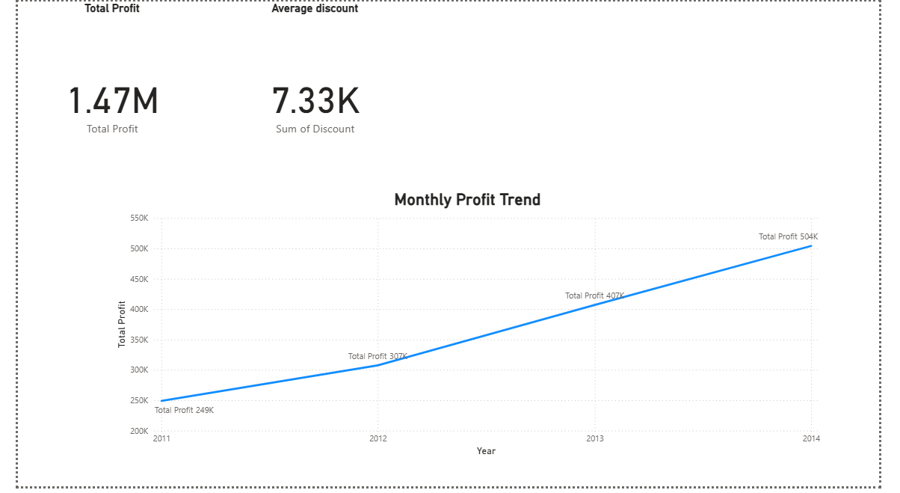

**Question 9 :**

**● Create a DAX Measure for Total Profit**

**● Use it in a Waterfall Chart to analyze how different Sub-Categories contribute to**

**overall profit**

**● Add a Slicer for Region to filter the visual**

**● Write brief business insights (4–5 lines) from the chart and provide 2–3 data-driven**

**recommendations to improve profit.**

**Answer: A DAX measure for total profit used in waterfall chart.**

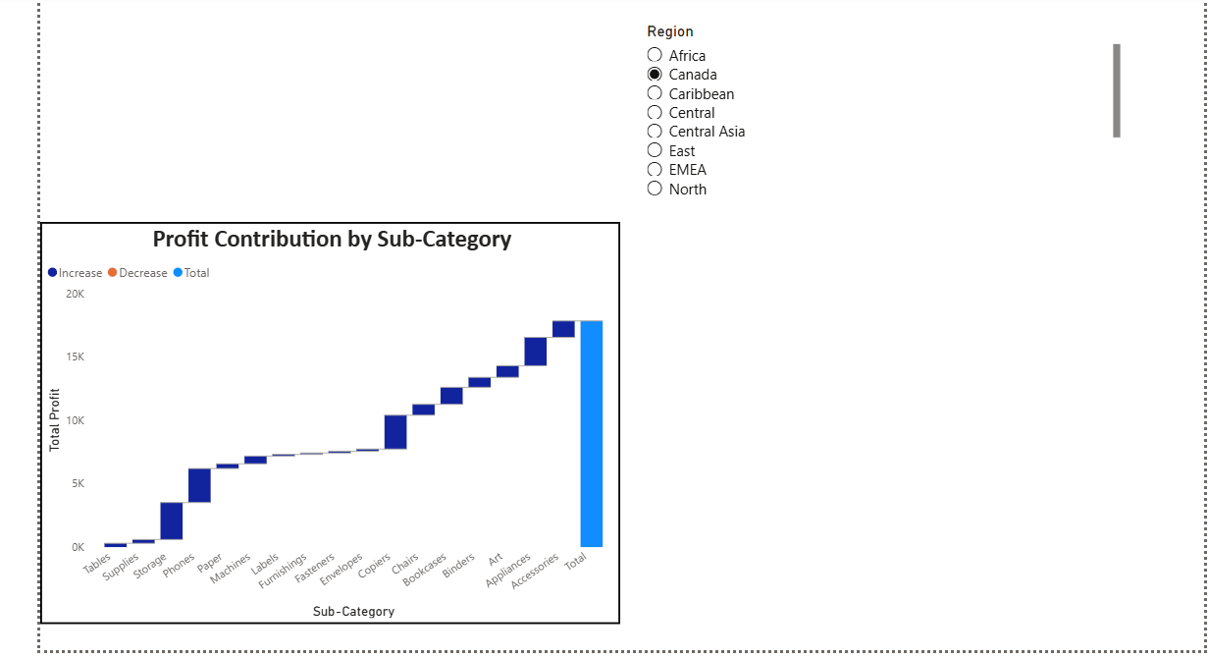

Business Insights

1. The Waterfall chart clearly shows that Phones, Copiers, and Chairs are the top profit contributors.
2. Tables and Bookcases show negative profit margins, indicating potential pricing or cost issues.
3. Most Technology sub-categories drive higher profit compared to Furniture or Office Supplies.
4. Regional filtering shows that Central and East regions have more balanced profit distribution, while some regions show losses in specific product lines.
5. Overall, the company is profit-positive but faces margin pressure in a few categories.

Data-Driven Recommendations

1. Reassess pricing or sourcing for loss-making sub-categories like *Tables* and *Bookcases* — possibly switch suppliers or increase prices slightly.
2. Boost sales in high-performing categories (*Phones*, *Copiers*) by offering bundled discounts or targeted marketing.
3. Region-specific strategy: Identify regions with consistently lower profits and optimize shipping costs or demand forecasting there.